HR DATA ANALYSIS ASSESSMENT ANSWER

1. Using Excel, how would you filter the dataset to only show employees aged 30 and above?

ANS. Click on the "Filter" button. Click on the drop-down arrow in the header cell of the "Age" column. This will display a list of unique values in that column. Then Number Filters>>Grater then and equal to 30.

1. Create a pivot table to summarize the average Monthly Income by Job Role

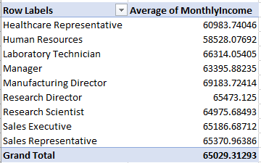

1. Apply conditional formatting to highlight employees with Monthly Income above the company's average income.

ANS. **Calculate the Company's Average Monthly Income:** =AVERAGE (Monthly Income values)

Select the Monthly Income Data>>Go to the "Home" Tab>>Click on "Conditional Formatting”>>Choose "New Rule">>Choose a Rule Type>>Set the Rule Criteria>>Define the Formatting:Click "OK">>Apply the Rule.

4 . Create a bar chart in Excel to visualize the distribution of employee ages.

ANS.

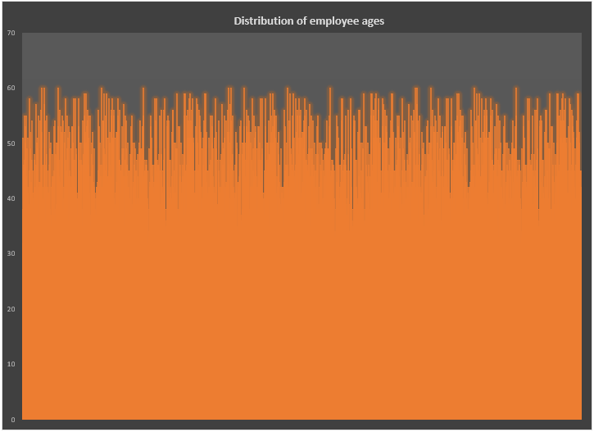

1. Identify and clean any missing or inconsistent data in the "Department" column.

ANS. There was no clean any missing or inconsistent data in the "Department" column.

1. In Power BI, establish a relationship between the "EmployeeID" in the employee data and the "EmployeeID" in the time tracking data.

ANS.

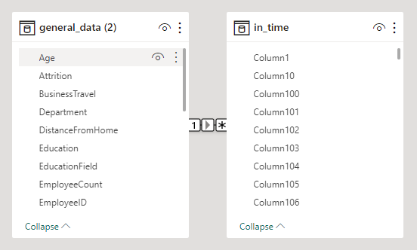

7. Using DAX, create a calculated column that calculates the average years an employee has spent with their current manager.

ANS.

AverageYearsWithManager =

    CALCULATE(

        AVERAGE('general_data (2)'[YearsWithCurrManager]),

        FILTER(

            'general_data (2)',

            'general_data (2)'[YearsWithCurrManager] <> BLANK()

        )

    )

1. Using Excel, create a pivot table that displays the count of employees in each Marital Status category, segmented by Department.

ANS.

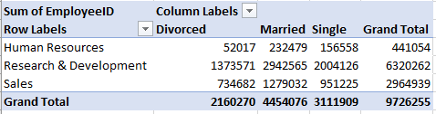

1. Apply conditional formatting to highlight employees with both above-average Monthly Income and above-average Job Satisfaction.

ANS.

=AND(MonthlyIncome > [average Monthly Income], JobSatisfaction > [average Job Satisfaction])

1. In Power BI, create a line chart that visualizes the trend of Employee Attrition over the years.

ANS.

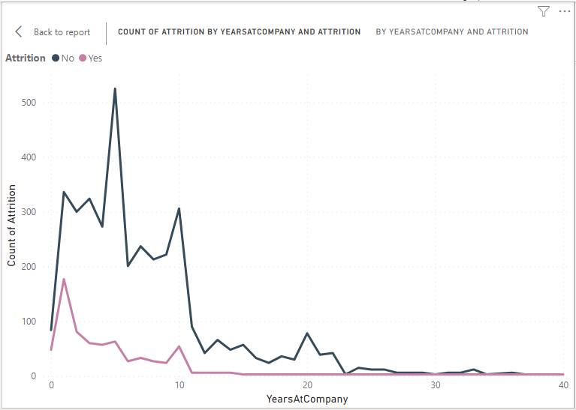

1. Describe how you would create a star schema for this dataset, explaining the benefits of doing so.

ANS.

**Create Dimension Tables**

EmployeeDimension = SELECTCOLUMNS('General_data (2)', EmployeeID, Age, Gender, MaritalStatus, Education, EducationField, BusinessTravel)

DepartmentDimension = SELECTCOLUMNS('General_data (2)', DepartmentID, DepartmentName)

JobDimension = SELECTCOLUMNS('General_data (2)', JobID, JobRole, JobLevel)

TrainingDimension = SELECTCOLUMNS('General_data (2)', TrainingID, TrainingType)

LocationDimension = SELECTCOLUMNS('General_data (2)', DistanceFromHome, City, State)

**Create Fact Table**

EmployeeFact = SELECTCOLUMNS('General_data (2)', EmployeeID, MonthlyIncome, NumCompaniesWorked, PercentSalaryHike, TrainingTimesLastYear, YearsAtCompany, YearsSinceLastPromotion, YearsWithCurrManager, DepartmentID, JobID, TrainingID, DistanceFromHome)

**Create Relationships**

CREATE RELATIONSHIP(EmployeeFact[EmployeeID], EmployeeDimension[EmployeeID])

CREATE RELATIONSHIP(EmployeeFact[DepartmentID], DepartmentDimension[DepartmentID])

CREATE RELATIONSHIP(EmployeeFact[JobID], JobDimension[JobID])

CREATE RELATIONSHIP(EmployeeFact[TrainingID], TrainingDimension[TrainingID])

CREATE RELATIONSHIP(EmployeeFact[DistanceFromHome], LocationDimension[DistanceFromHome])

**Benefits of the Star Schema:**

* Simplicity
* Improved Query Performance
* Flexibility in Reporting
* Easier Maintenance
* Scalability
* Support for OLAP Cubes

1. Using DAX, calculate the rolling 3-month average of Monthly Income for each employee.

ANS.

Rolling3MonthAverage =

CALCULATE(

    AVERAGEX(

        FILTER(

            ALL('general_data (2)'),

            'general_data (2)'[EmployeeID] = EARLIER('general_data (2)'[EmployeeID]) &&

            'general_data (2)'[YearsAtCompany] >= EARLIER('general_data (2)'[YearsAtCompany]) - 0.25 &&

            'general_data (2)'[YearsAtCompany] <= EARLIER('general_data (2)'[YearsAtCompany])

        ),

        'general_data (2)'[MonthlyIncome]

    )

)

1. Create a hierarchy in Power BI that allows users to drill down from Department to Job Role to further narrow their analysis.

ANS.

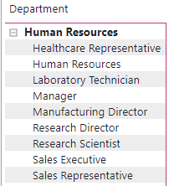

1. How can you set up parameterized queries in Power BI to allow users to filter data based on the Distance from Home column?

ANS.

= Table.SelectRows(#"Changed Type", each ([DistanceFromHome] <= DistanceParameter))

1. In Excel, calculate the total Monthly Income for each Department, considering only the employees with a Job Level greater than or equal to 3.

ANS.

=SUMIFS($N$2:$N$4411,$K$2:$K$4411,">="&3,$D$2:$D$4411,D2)

1. Explain how to perform a What-If analysis in Excel to understand the impact of a 10% increase in Percent Salary Hike on Monthly Income.

ANS.

### Using Data Table

### Using Scenario Manager

### Verify if the data adheres to a predefined schema. What actions would you take if you find inconsistencies?

ANS.

Verifying if data adheres to a predefined schema involves checking if the data conforms to the expected structure, data types, and constraints defined for each column or attribute. If you find inconsistencies, it's crucial to take appropriate actions to ensure data quality. Here are steps can take:

### 1. Understand the Predefined Schema

### 2. Perform Data Profiling

### 3. Check Data Types

### 4. Validate Constraints

### 5. Identify Missing Values

### 6. Handle Duplicates

### 7. Address Outliers

### 8. Data Cleaning

### 9. Document Inconsistencies

### 10. Collaborate with Stakeholders

### 11. Implement Data Quality Checks

### 12. Iterate and Improve